ICVGoggles Github URL: https://github.com/bmomen/ICVGoggles

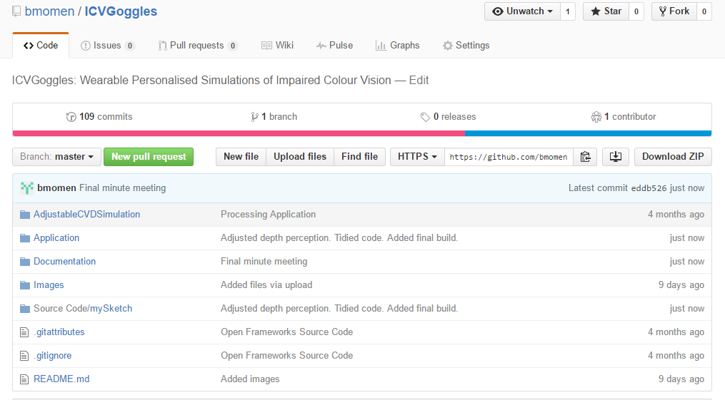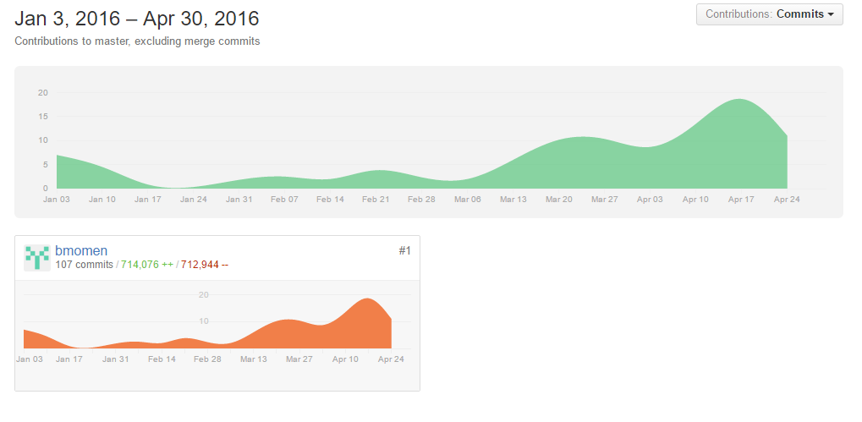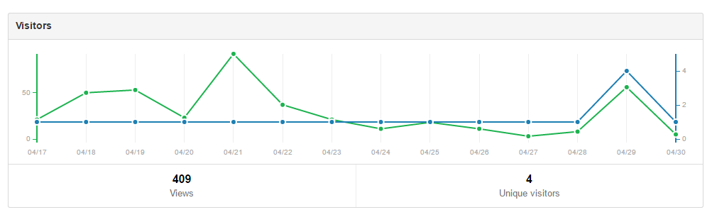

Commit Punchcard

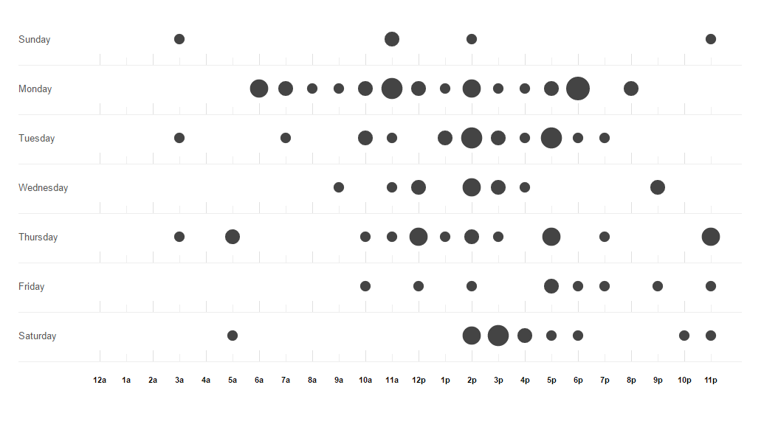

This displays when the student sent work to the repository and at what time. The larger the circle, the more commits made in that hour.

